## Hospital Management System using Flask

1. Create a database in mongoDB and write the database name in config.py
2. Create a class userstore in models.py and according to the fields specified here add an admin to the userstore table in mongodb manually-

Only the admin user will be able to add new hospital staff to the database and view all staff in the database.

**Admin**

The admin user should login using the credentials provided in the database in step 2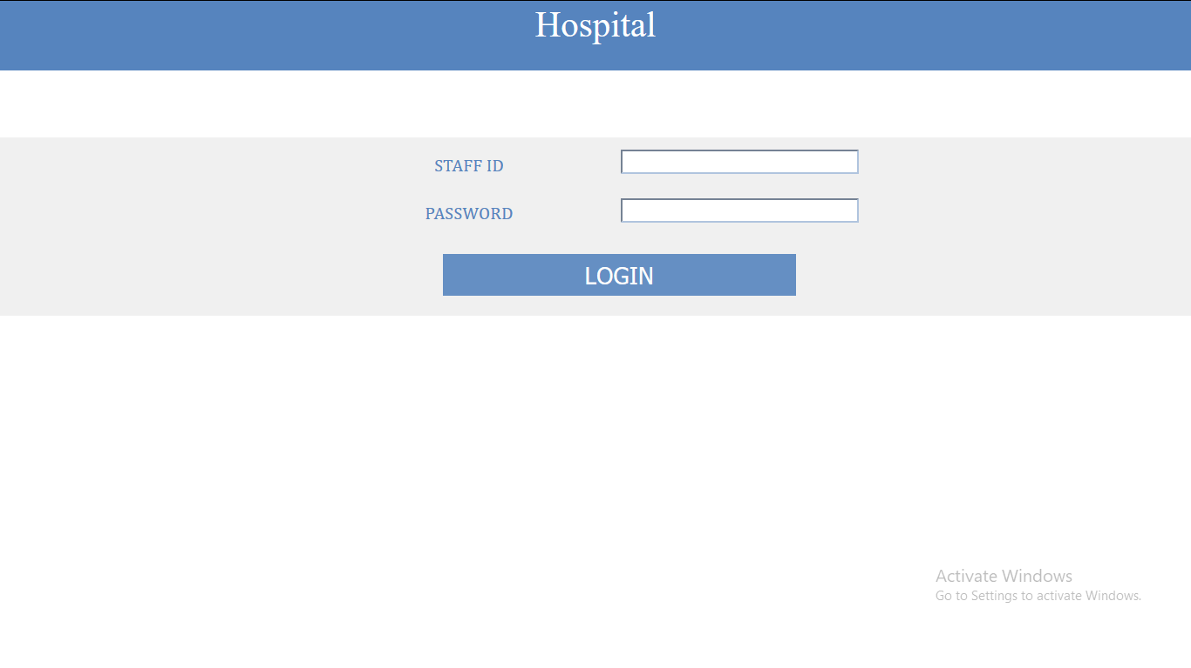

Enter the credentials to login and add a new staff. Each staff will have a unique login ID which they will use to login in into the system. A staff member can be a part of one of the three departments:

* Reception
* Pharmacy
* Diagnosis

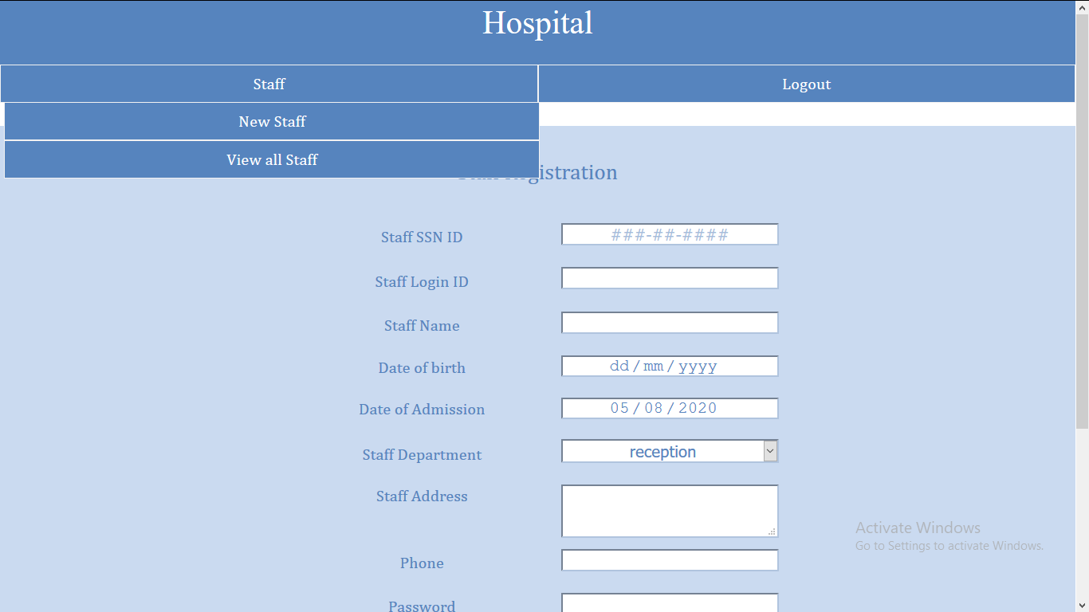

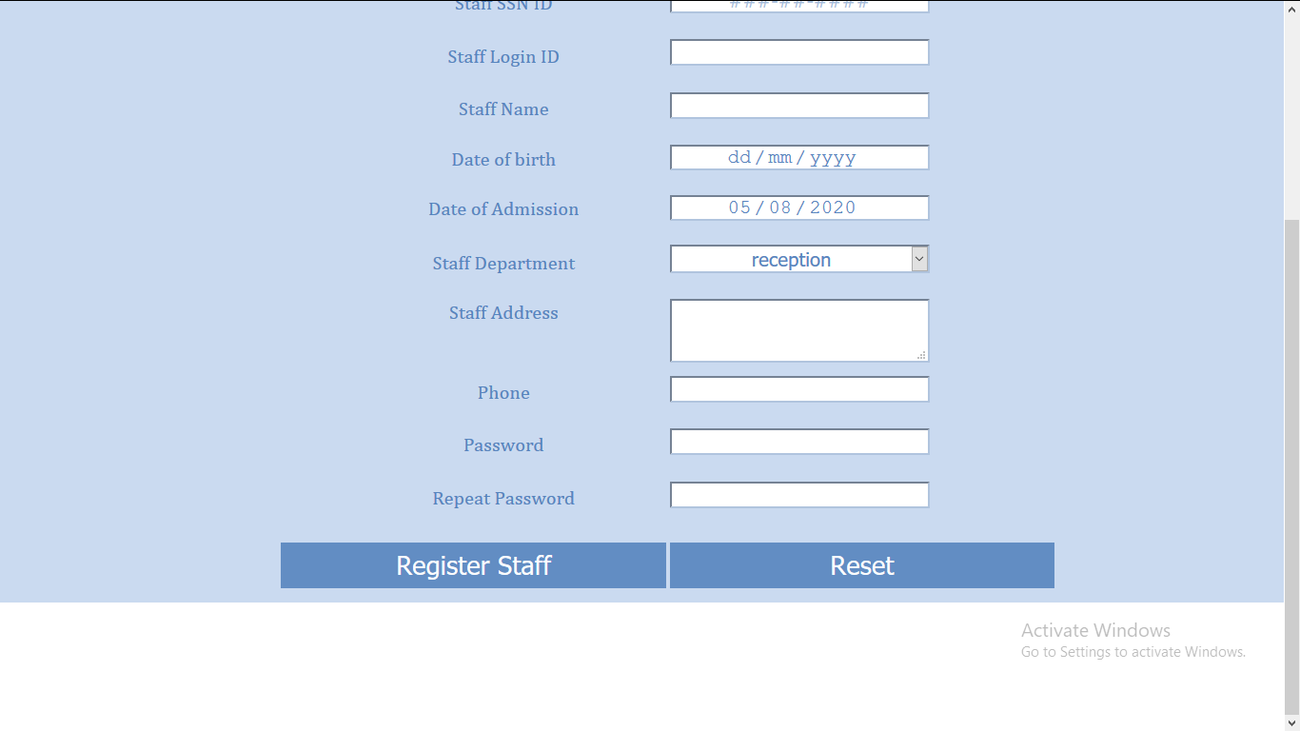

**Reception staff**

After login, the staff in the reception department will be redirected to this page.

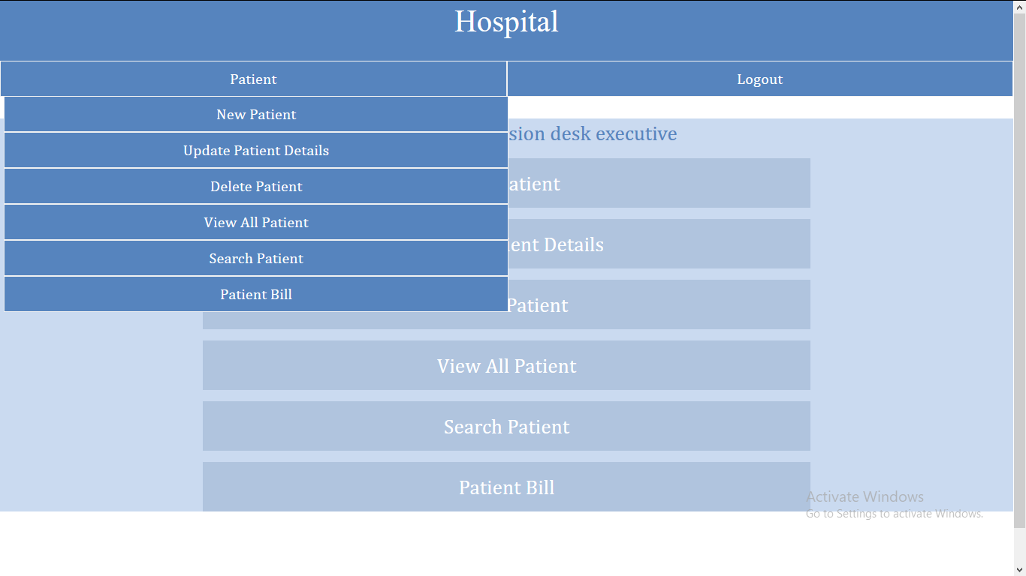

The reception staff can perform the following actions:

* Add a new patient

The staff can only add a patient that is not already in the database.

After registration the system generates a unique 9 digit patient ID which can be used to view, update, remove , issue medicines, add tests and to generate the patient’s bill

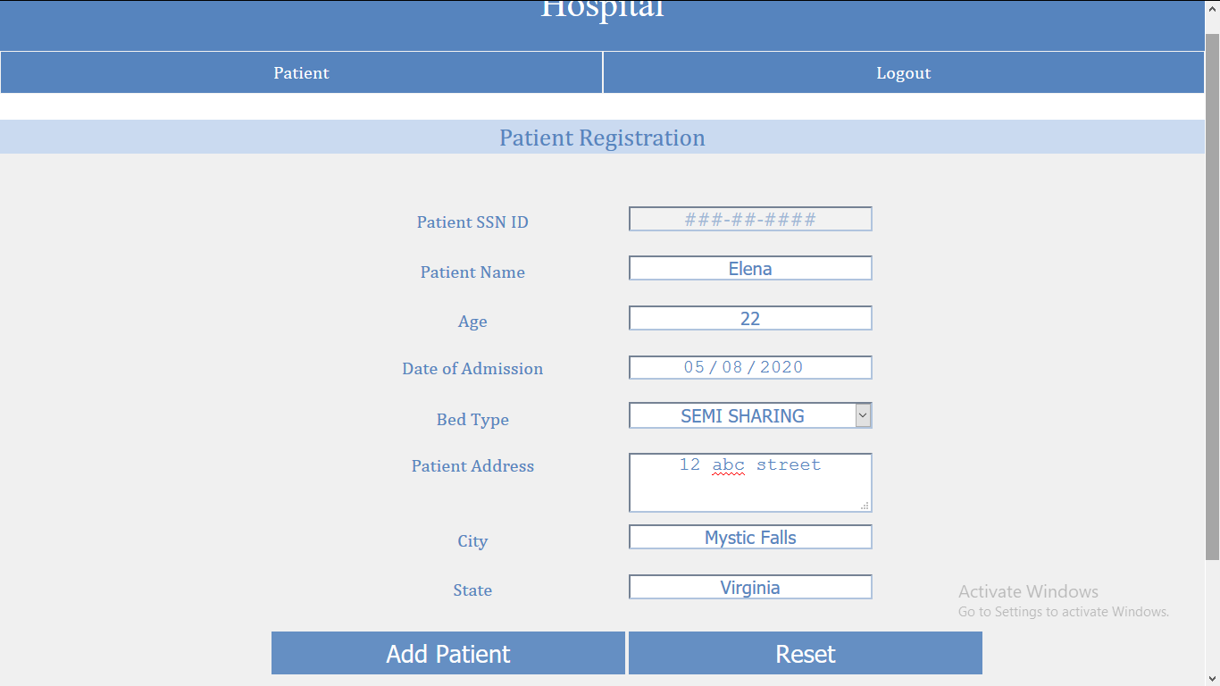

* Update a patient’s details

The staff is to provide the patient’s ID (generated at the time of registration) and all the details, except SSN ID, can be updated.

If the patient was already discharged, he/she can be admitted again but their admission date has to be after the date they were discharged. After a valid submission, the patient’s status will be set to active.

If the patient was not found in the database an error message will be displayed.

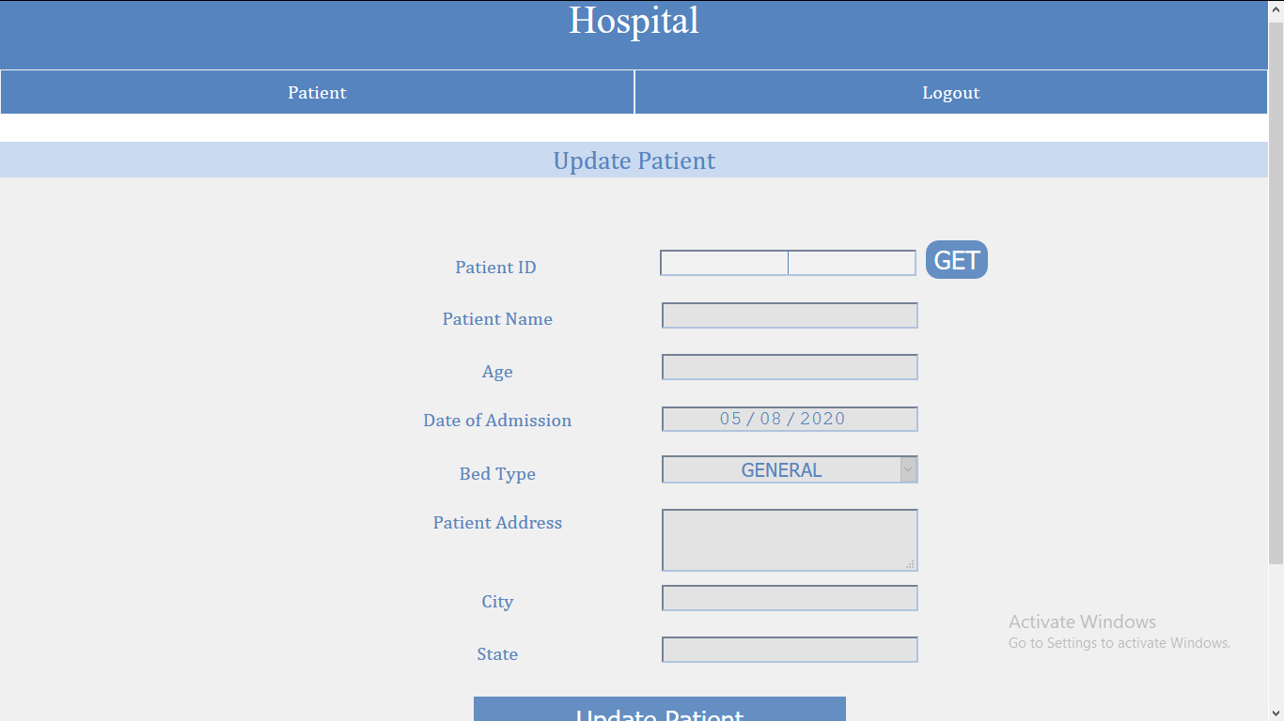

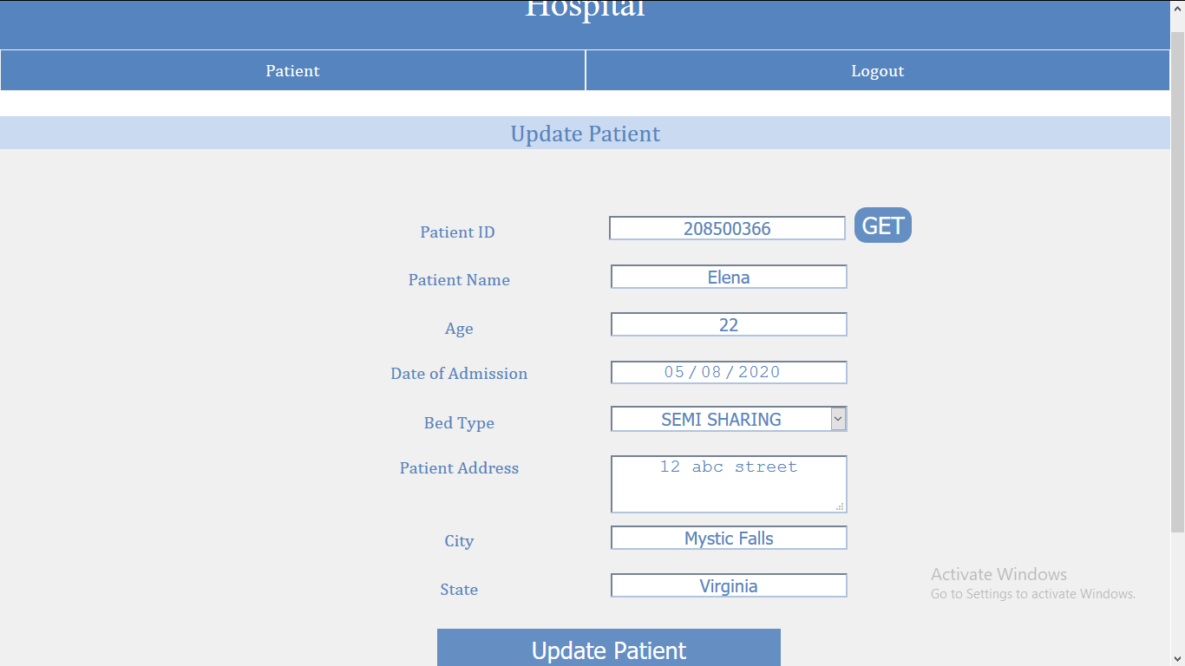

* Delete a patient from database

The staff is to provide the patient’s ID as an input and the details of the patient will be displayed if the patient exists in the database. After clicking on the “Delete” button the details of the patient will be deleted from the database forever. All the medicines issued and the tests assigned to the patient will also be removed.

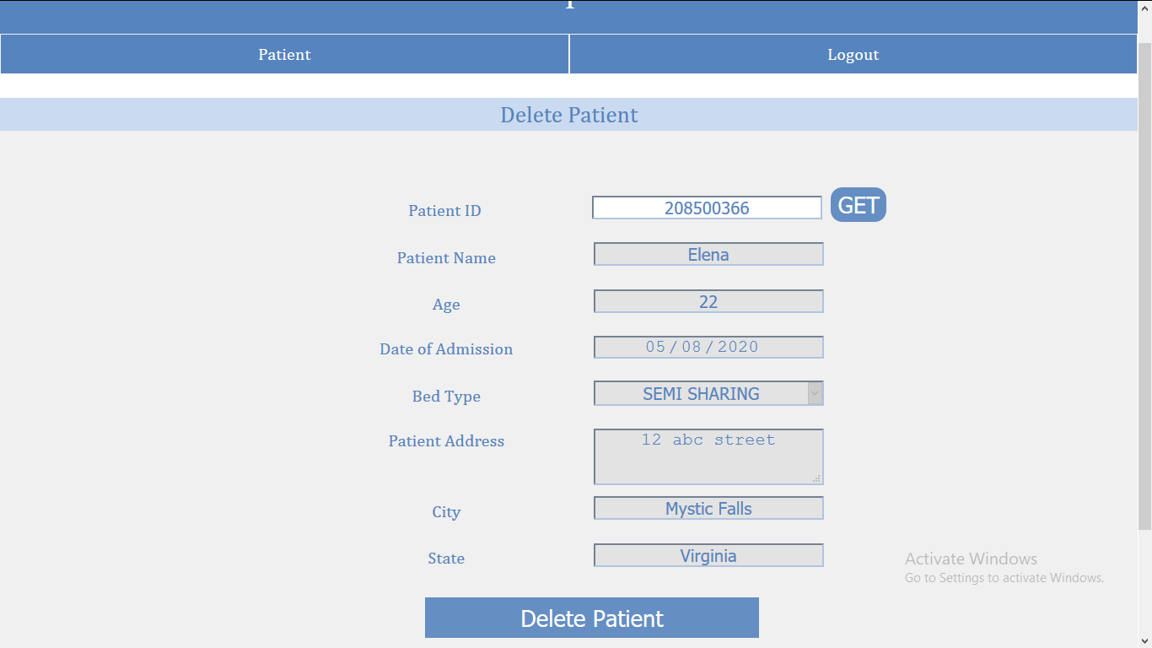

* View all patients in the database

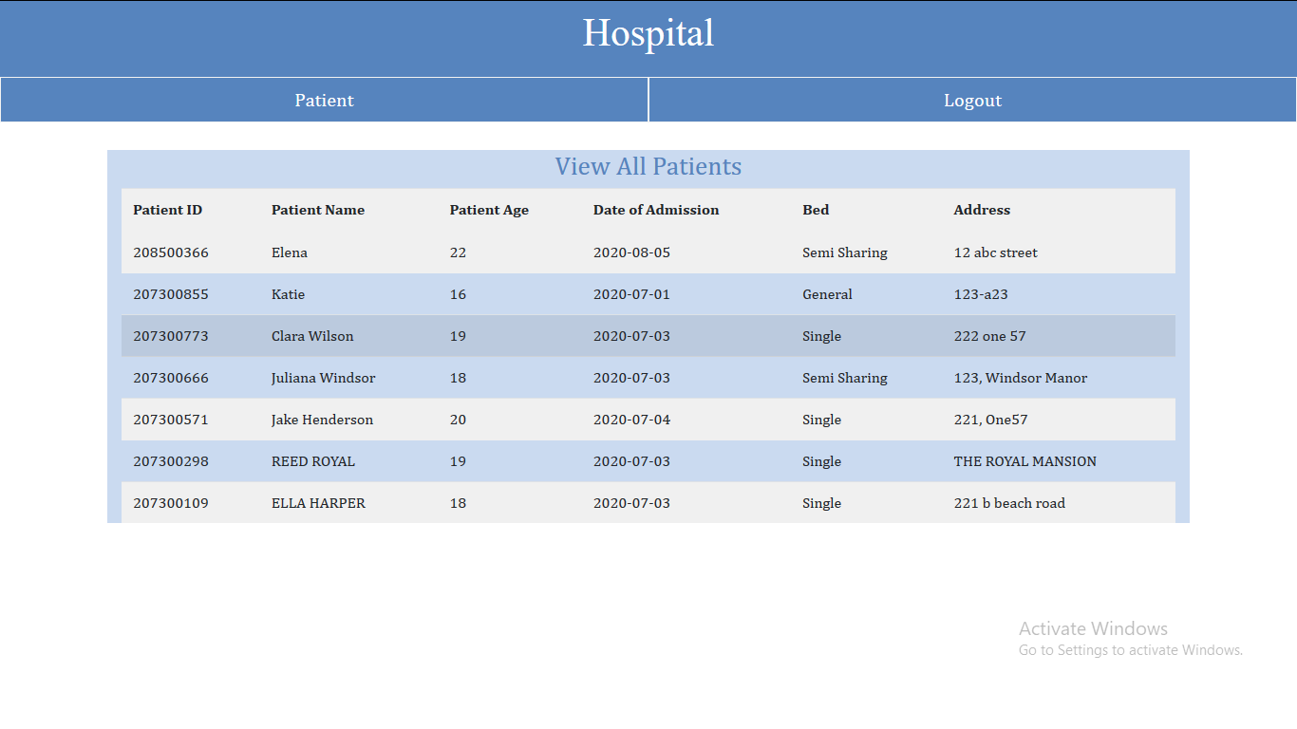

* Search for a particular patient’s details

Provide patient’s ID as an input and check the details of the patient if they exist

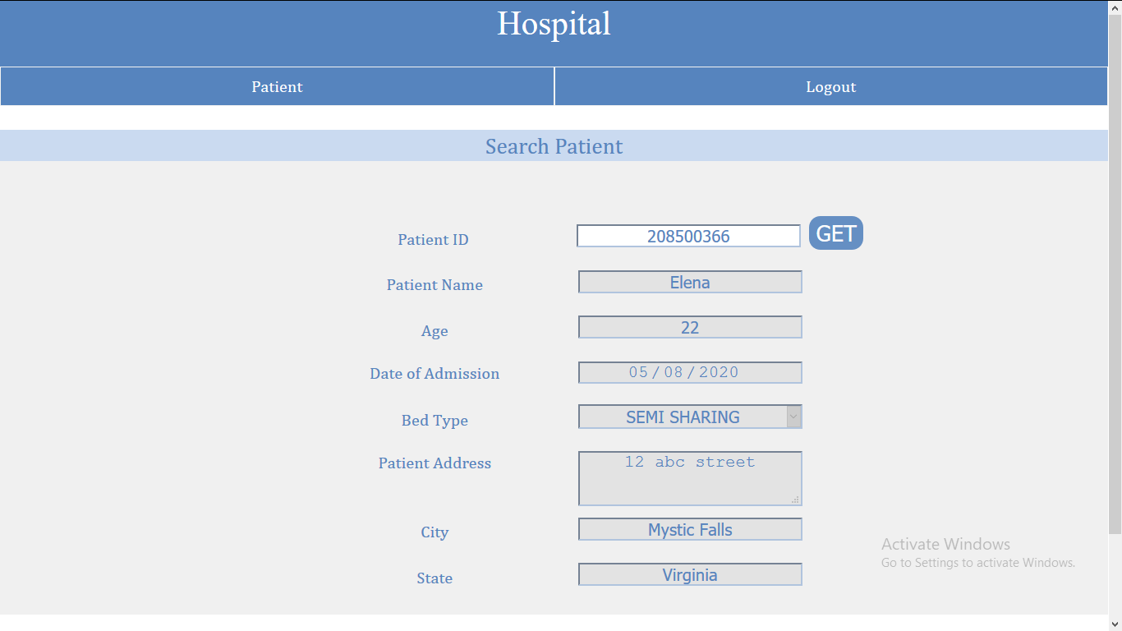

* Generate bill for a particular patient

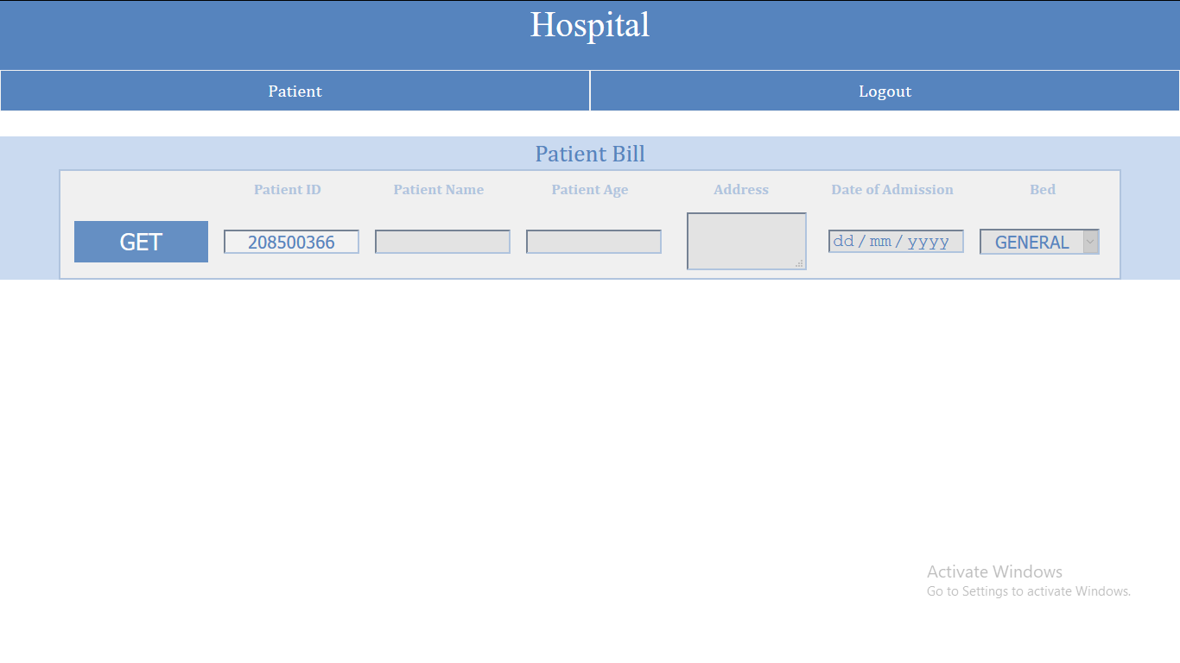

To generate the bill for the patient, staff should provide the patient's ID as an input and all the details about the patient’s stay at the hospital, his/her medicine and test bill will be displayed on the screen.

To print the bill the click on the “Print Bill” option which will provide a prompt to print the bill. This will add the current date and time of bill generation and the staff’s ID who is discharging the patient.

To discharge the patient click “Confirm” and the patient will be discharged. The medicine and tests issued to the patient will be updated and set as paid.

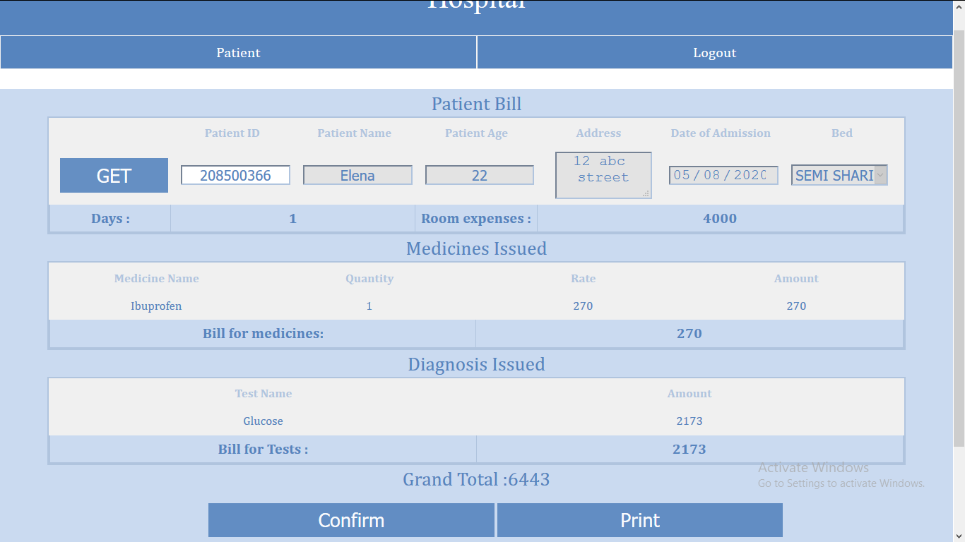

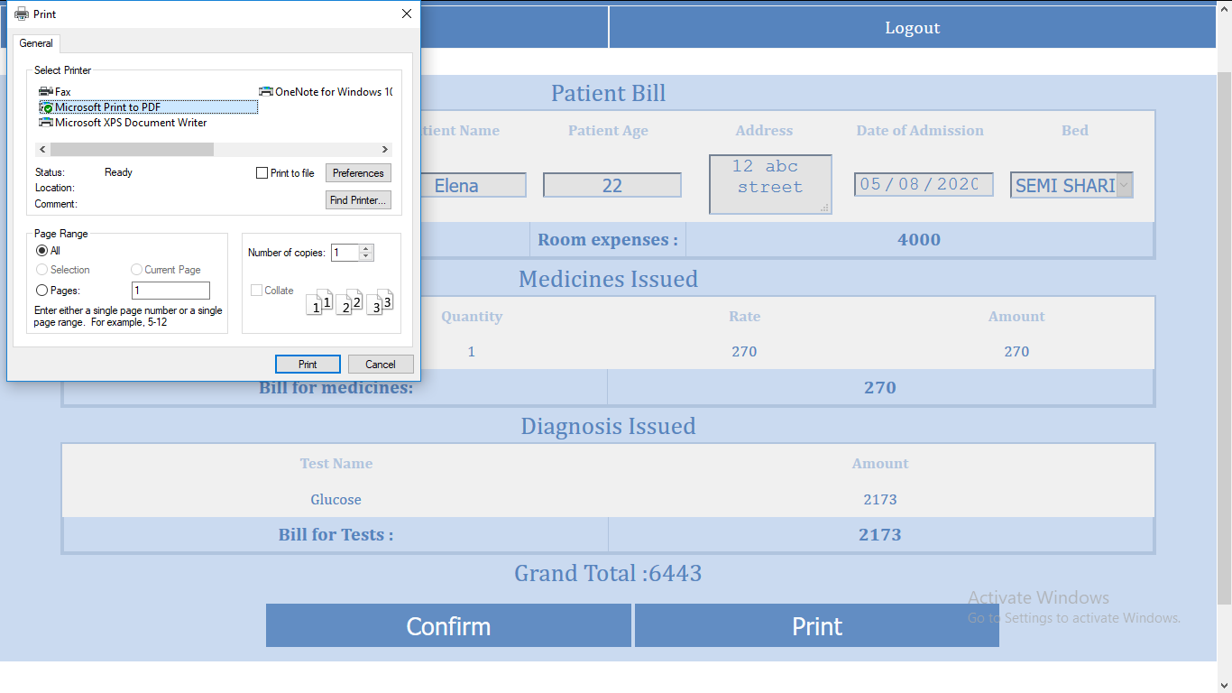

**Pharmacy**

For staff that are in the pharmacy department, they will be redirected to this page

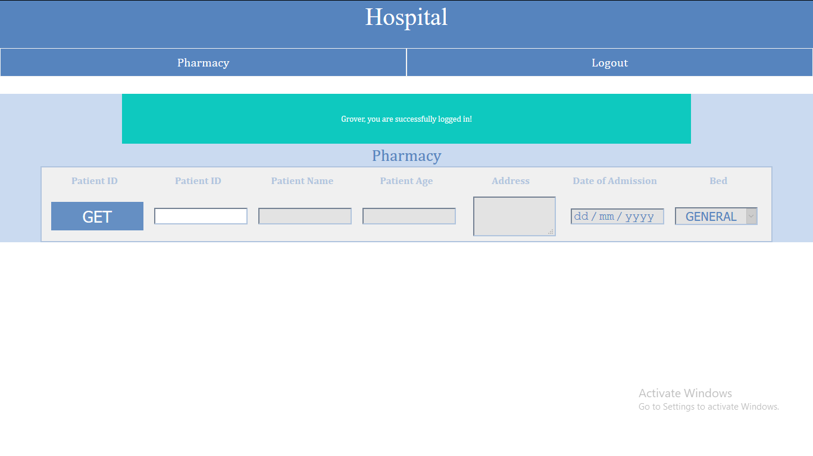

Staff in this department can perform following actions:

* View all medicines issued to a patient

The staff is to enter a patient’s ID and they can view all the medicine previously issued to the patient they they haven’t paid for

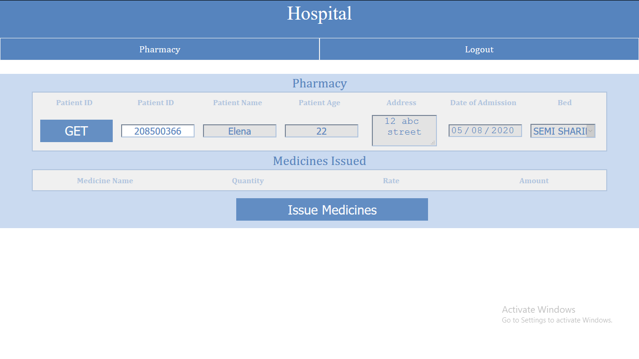

* Issue medicine new medicines to a patient

New medicines can be issued to the patient by clicking on the “Issue Medicines” button. The medicine can be added to a patient's account if it is available in stock. Otherwise a message is displayed saying not available in stock.

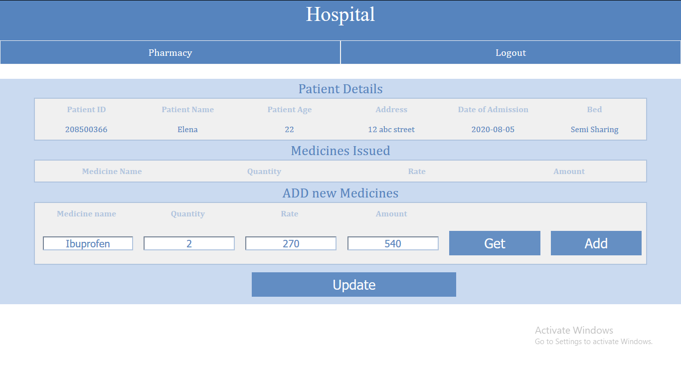

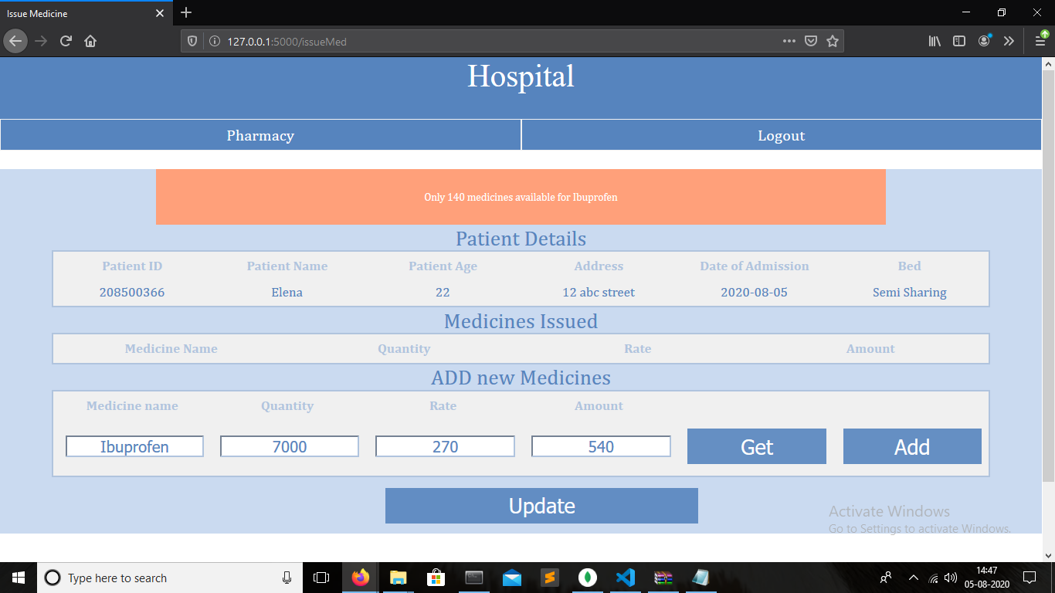

**Diagnostics**

For staff that are in the Diagnostics department, they will be redirected to this page

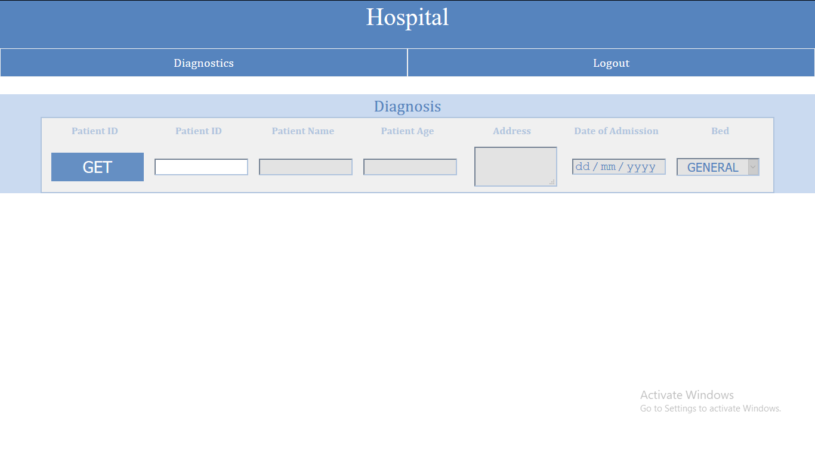

Members of this department can perform following actions:

* View all the tests assigned to the patient

Provide the patient’s ID as an input and view all the tests assigned to the patient

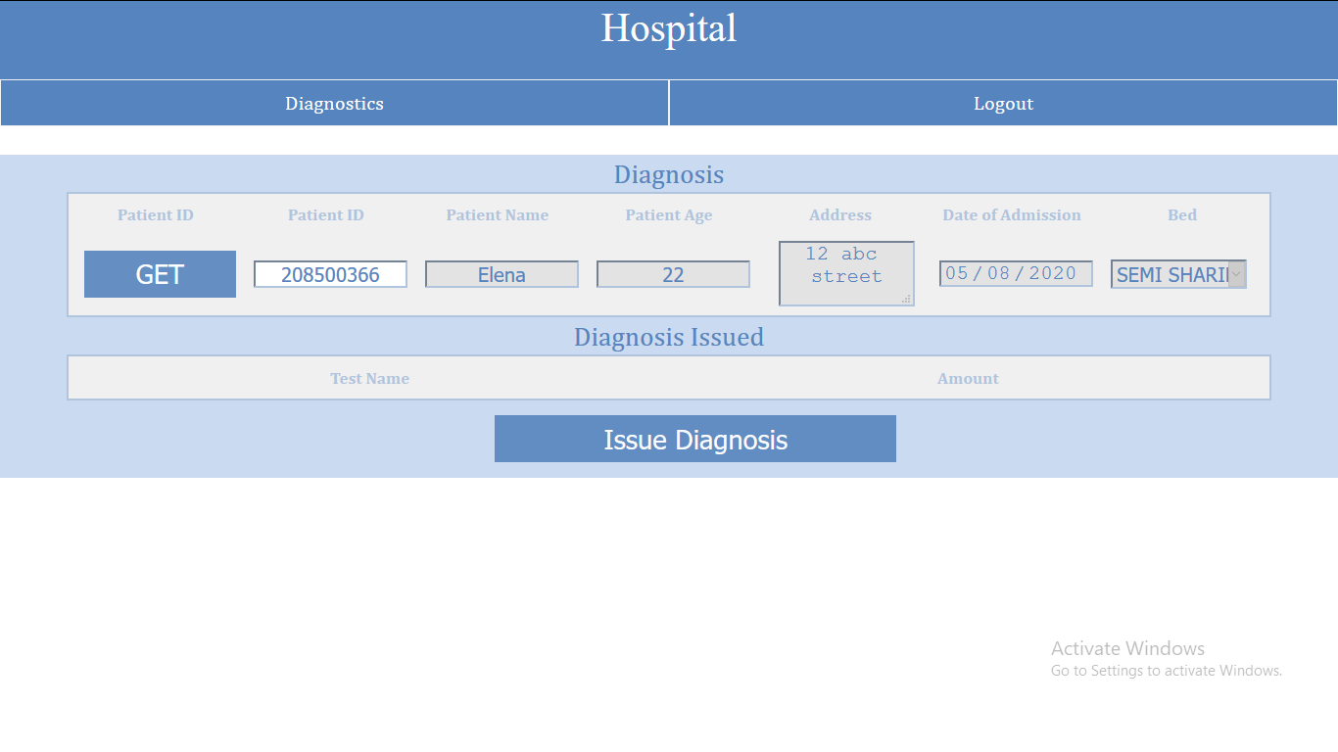

* Issue a new test to the patient

Select the test to add and check the price. Click on “ADD” button to add a test

